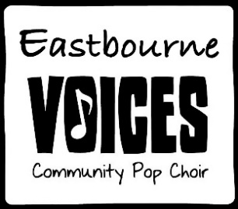

Get the party started

Get this party started on a Saturday night   
Everybody’s waiting for me to arrive  
I got lots of style, check my gold diamond rings  
I can go for miles, if you know what I mean  
  
I'm coming up so you better get this party started  
I'm coming up so you better get this party started  
  
Sending out the message to all of my friends  
We’ll be looking classy in my Mercedez-Benz  
I got lots of style, check my gold diamond rings  
I can go for miles, if you know what I mean  
Get this party started on a Saturday night  
Everybody’s waiting for me to arrive  
  
I'm coming up so you better get this party started  
I'm coming up so you better get this party started  
  
Pumping up the volume, breaking down to the beat  
Cruising through the West Side, we’ll be checking the scene  
Boulevard is freaking as I’m coming up fast  
I’ll be burning rubber, you’ll be kissing my hand  
Pull up to the bumper, get out of the car  
License plate says “stunner”, number one superstar

I'm coming up so you better get this party started  
I'm coming up so you better get this party started  
  
Get this party started, get this party started  
Get this party started, get this party started  
  
Making my connection as I enter the room  
Everybody’s chilling as I set up the groove  
Pumping up the volume with this brand new beat  
Everybody’s dancing and they're dancing for me  
I'm your operator you can call anytime  
I'll be your connection to the party line  
  
I'm coming up so you better get this party started  
I'm coming up so you better get this party started

Get this party started, get this party started  
Get this party started, get this party started  
Get this party started  
This party started