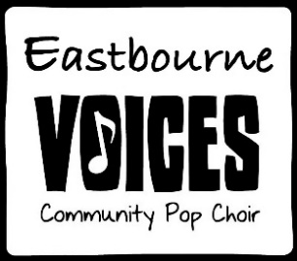

House of the rising sun

There is a house in New Orleans they call the Rising Sun  
And it's been the ruin of many a poor boy  
And God, I know I’m one

My mother was a tailor, she sewed my new blue jeans  
My father was a gambling man  
Down in New Orleans

Now the only thing a gambler needs is a suitcase and a trunk  
And the only time he is satisfied  
Is when he's on a drunk  
  
Oh, mother, tell your children not to do what I have done  
Spend your lives in sin and misery  
In the house of the rising sun  
  
I got one foot on the platform, the other on the train  
And I'm going back to New Orleans  
To wear that ball and chain  
  
There is a house in New Orleans they call the Rising Sun  
And it's been the ruin of many a poor boy  
And God, I know I’m one  
  
And God, I know I’m one