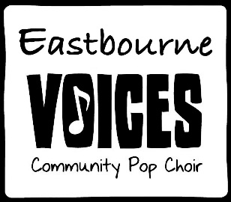

We built this city

Say you don't know me or recognize my face  
Say you don't care who goes to that kind of place  
Knee deep in the hoopla, sinking in your fight  
Too many runaways eating up the night  
  
Marconi plays the mamba, listen to the radio  
Don't you remember?  
We built this city, we built this city on rock and roll  
  
We built this city, we built this city on rock and roll  
Built this city, we built this city on rock and roll  
  
Someone's always playing corporation games  
Who cares, they're always changing corporation names  
We just want to dance here, someone stole the stage  
They call us irresponsible, write us off the page  
  
Marconi plays the mamba, listen to the radio  
Don't you remember?  
We built this city, we built this city on rock and roll

We built this city, we built this city on rock and roll  
Built this city, we built this city on rock and roll  
  
It's just another Sunday in a tired old street  
Police have got the choke hold, oh, then we just lost the beat  
  
Who counts the money underneath the bar?  
Who rides the wrecking ball into our guitars?  
Don't tell us you need us 'cause we're the ship of fools  
Looking for America, coming through your schools  
  
Marconi plays the mamba, listen to the radio  
Don't you remember?  
We built this city, we built this city on rock and roll  
  
We built this city, we built this city on rock and roll  
Built this city, we built this city on rock and roll  
  
We built this city, we built this city on rock and roll  
Built this city, we built this city on rock and roll