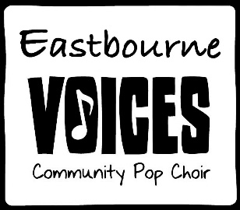

Feeling good

Birds flying high, you know how I feel  
Sun in the sky, you know how I feel  
Breeze drifting on by, you know how I feel

It's a new dawn  
It's a new day  
It's a new life for me  
And I'm feeling good

Fish in the sea, you know how I feel  
River running free, you know how I feel  
Blossom on a tree, you know how I feel

It's a new dawn

It's a new day  
It's a new life for me  
And I'm feeling good

Dragonfly out in the sun, you know what I mean, don't you know  
Butterflies all having fun, you know what I mean  
Sleep in peace when day is done, that's what I mean  
And this old world is a new world  
And a bold world for me  
For me

Stars when you shine, you know how I feel  
Scent of the pine, you know how I feel  
Oh, freedom is mine and I know how I feel

It's a new dawn, it's a new day, it's a new life

It's a new dawn, it's a new day, it's a new life

It's a new dawn, it's a new day, it's a new life  
It's a new life for me

And I'm feeling good