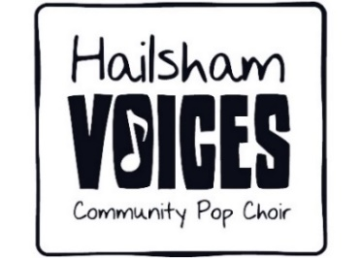

Don’t stop

If you wake up and don't want to smile  
If it takes just a little while  
Open your eyes and look at the day  
You'll see things in a different way  
  
Don't stop thinking about tomorrow  
Don't stop, it'll soon be here  
It'll be better than before  
Yesterday's gone, yesterday's gone  
  
Why not think about times to come  
And not about the things that you've done  
If your life was bad to you  
Just think what tomorrow will do  
  
Don't stop thinking about tomorrow  
Don't stop, it'll soon be here  
It'll be better than before  
Yesterday's gone, yesterday's gone

All I want is to see you smile  
If it takes just a little while  
I know you don't believe that it's true  
I never meant any harm to you  
  
Don't stop thinking about tomorrow  
Don't stop, it'll soon be here  
It'll be better than before  
Yesterday's gone, yesterday's gone  
  
Don't stop thinking about tomorrow  
Don't stop, it'll soon be here  
It'll be better than before  
Yesterday's gone, yesterday's gone  
  
(Ooh) don't you look back  
(Ooh) don't you look back  
(Ooh) don't you look back  
(Ooh) don't you look back