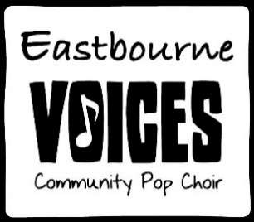

Say something

Say something, I'm giving up on you  
I'll be the one, if you want me to  
Anywhere, I would've followed you  
Say something, I'm giving up on you

And I am feeling so small  
It was over my head, I know nothing at all  
And I will stumble and fall  
I'm still learning to love, just starting to crawl

Say something, I'm giving up on you  
I'm sorry that I couldn't get to you  
Anywhere, I would've followed you  
Say something, I'm giving up on you

And I will swallow my pride  
You're the one that I love, and I'm saying goodbye

Say something, I'm giving up on you  
And I'm sorry that I couldn't get to you  
And anywhere, I would have followed you  
Oh, say something, I'm giving up on you  
  
Say something, I'm giving up on you  
Say something