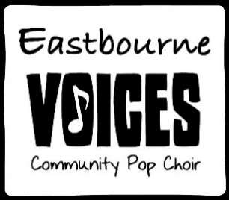

Walking on sunshine

I used to think maybe you loved me, now baby I'm sure  
And I just can't wait till the day when you knock on my door  
Now every time I go for the mailbox, gotta hold myself down  
'Cause I just can't wait till you write me you're coming around

I'm walking on sunshine, wooah  
I'm walking on sunshine, wooah  
I'm walking on sunshine, wooah  
And don't it feel good!  
Hey, alright now  
And don’t it feel good!

I used to think maybe you loved me, now I know that it's true  
And I don't want to spend my whole life just waiting for you  
Now I don't want you back for the weekend  
Not back for a day, no no  
I said baby I just want you back and I want you to stay  
Woah yeah!

I'm walking on sunshine, wooah  
I'm walking on sunshine, wooah  
I'm walking on sunshine, wooah  
And don't it feel good!  
Hey, alright now  
And don't it feel good!  
Yeah, oh yeah  
And don't it feel good!

Walking on sunshine  
Walking on sunshine

I feel alive, I feel the love, I feel the love that's really real  
I feel alive, I feel the love, I feel the love that's really real

I'm on sunshine baby, yeah  
I'm on sunshine baby, yeah

I'm walking on sunshine, wooah  
I'm walking on sunshine, wooah  
I'm walking on sunshine, wooah  
And don't it feel good!  
Hey, alright now  
And don't it feel good!  
I'll say it, say it, say it again now  
And don't it feel good!

Oh, yeah  
And don't it feel good!  
Now don't it, don't it, don't it, don't it, don't it, don't it feel good!  
I'll say it, say it, say it again now  
And don't it feel good!

Now don't it, don't it, don't it, don't it, don't it, don't it feel good!  
Tell me, tell me, tell me again now  
And don't it feel good!  
Oh, yeah  
And don't it feel good!