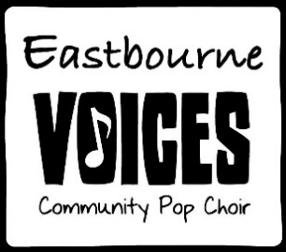

Somewhere only we know

I walked across an empty land  
I knew the pathway like the back of my hand  
I felt the earth beneath my feet  
Sat by the river and it made me complete

Oh, simple thing, where have you gone?  
I'm getting old and I need something to rely on  
So tell me when you're gonna let me in  
I'm getting tired, and I need somewhere to begin

I came across a fallen tree  
I felt the branches of it looking at me  
Is this the place we used to love?  
Is this the place that I've been dreaming of?

Oh, simple thing, where have you gone?  
I'm getting old, and I need something to rely on  
So tell me when you're gonna let me in  
I'm getting tired, and I need somewhere to begin

And if you have a minute, why don't we go  
Talk about it somewhere only we know?  
This could be the end of everything  
So why don't we go  
Somewhere only we know?  
Somewhere only we know

Oh, simple thing, where have you gone?  
I'm getting old and I need something to rely on  
So tell me when you're gonna let me in  
I'm getting tired and I need somewhere to begin

And if you have a minute, why don't we go  
Talk about it somewhere only we know?  
This could be the end of everything  
So why don't we go somewhere only we know?